Cross-Platform Mobile Application Development with Xamarin: Module 3, Lesson 6

Build a Basic Android app using Xamarin.Forms Lab

Overview

Xamarin is a powerful tool that allows you to develop mobile applications across all major mobile platforms. This lab will cover how to build a very basic iOS application using Xamarin.iOS.

Objectives

In this hands-on lab you will learn how to:

* Interact with Xamarin.Forms, specifically in the context of building a simple Android app
* Create a text input field
* Display a dialog box on the click of a button

Prerequisites

The following are required to complete this hands-on lab:

* Visual Studio with Xamarin installed or Xamarin Studio for OS X
* Completion of [Module 3 Lessons 1-10](https://github.com/MSFTImagine/computerscience/tree/master/Instructor-Led/Module3/Lessons) and [Module 5 Lesson 5 and 6 Labs](https://github.com/MSFTImagine/computerscience/tree/master/Instructor-Led/Module3/Labs)

Exercises

This hands-on lab includes the following exercises:

* Exercise 1: Create a First Name Entry UI

Exercise 1: Create a First Name Entry UI

Create a First Name Entry UI that displays the name in a popup when the button is clicked.

1. Create a Visual Studio Visual C#> Cross-platform > Blank App (Xamarin.Forms Portable) Project.
2. Create a custom page in the Xamarin.Forms core project and set it to be the app’s main page. Create a class inherited from ContentPage and call it NamePage.

using Xamarin.Forms;

namespace Mobile3_Lab3_Forms

{

class NamePage : ContentPage

{

public NamePage()

{

// views/controls will go here

}

}

}

1. Now instantiate the new page. In Xamarin.Forms project’s App.cs, update the App constructor to set an instance of NamePage as the MainPage:

namespace Mobile3_Lab3_Forms

{

public class App : Application

{

public App()

{

MainPage = new NamePage();

}

1. New add some views to NamePage.cs using C# (you could also use XAML but this is a C# example).
   * Add a Label with a with a text value of “First Name”.

Label labelFirst = new Label

{

Text = "First Name",

FontSize = Device.GetNamedSize(NamedSize.Large, typeof(Label)),

HorizontalOptions = LayoutOptions.FillAndExpand

};

* + Add an Entry control called firstName with a Placeholder of “enter name”.

Entry firstName = new Entry

{

Placeholder = "enter name",

FontSize = Device.GetNamedSize(NamedSize.Medium, typeof(Entry)),

HorizontalOptions = LayoutOptions.FillAndExpand,

Keyboard = Keyboard.Text

};

* + Add a Button called submitName with Text of “Submit”.

Button submitName = new Button

{

Text = "Submit",

FontSize = 25,

HorizontalOptions = LayoutOptions.FillAndExpand

};

1. Place the views on a layout. A Layout view acts as a container for other views. Since a ContentPage can have only one child, all the views on our page must be placed in a single container that is made the child of the ContentPage. Use a StackLayout, a subclass of Layout that can “stack” child views vertically:

StackLayout stackLayout = new StackLayout

{

Children =

{

labelFirst,

firstName,

submitName

},

HeightRequest = 1500

};

1. To get the StackLayout to display on our page, we must assign it to the Content property of the ContentPage:

this.Content = stackLayout;

The views look like this on the page and tapping “enter name” will invoke a keyboard.

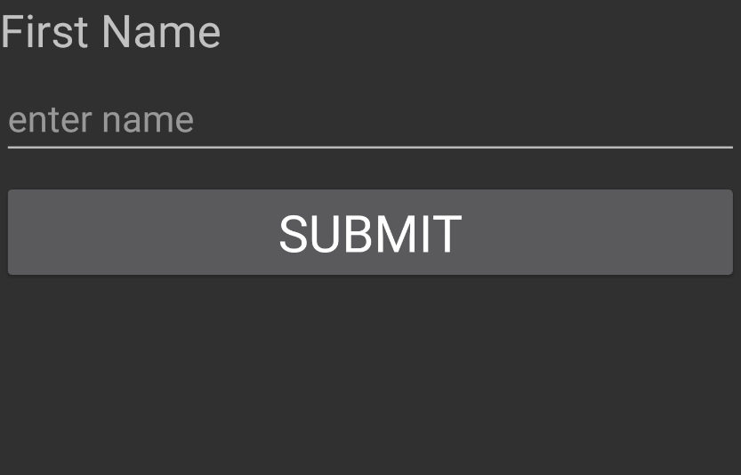

1. In the NamePage, make the button click event show the firstName value in a popup.

Handle the button’s Click event.

button.Click += delegate { … }

OR

button.Click += (object sender, EventArgs e) => {…}

In the button’s event, use DisplayAlert to create a popup displaying the name in the firstName view. Using async/await with popups is good practice to help prevent the UI from locking up.

submitName.Clicked += async (sender, e) =>

{

await DisplayAlert("Name", firstName.Text, "OK");

};

Entering a name and tapping the button raises the alert.

